Introduction To Data Science
Name: Abdullah Ayub
Roll NO: BSDSF24M029

Task1:
I created a GitHub repository called my-first-repo, cloned it locally, created a README.md file, committed it with git commit, and pushed it to the remote repository. The repository now shows the README on GitHub.
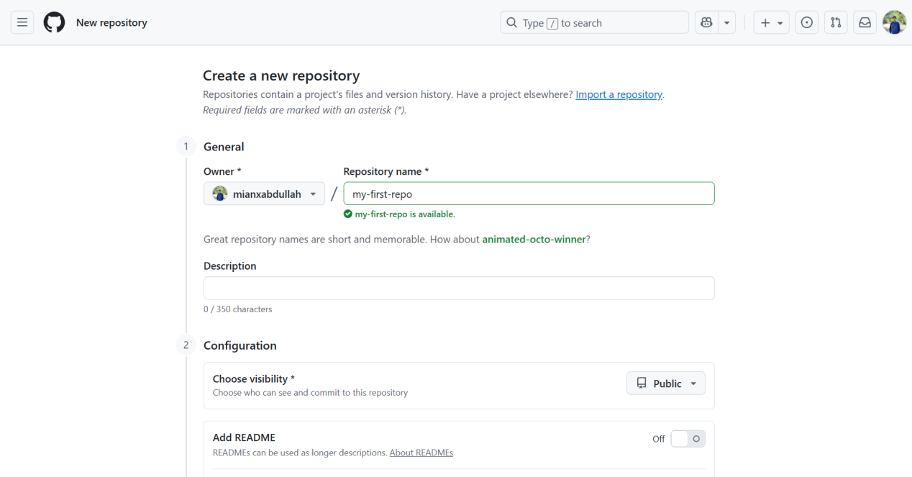
  - made repository on github
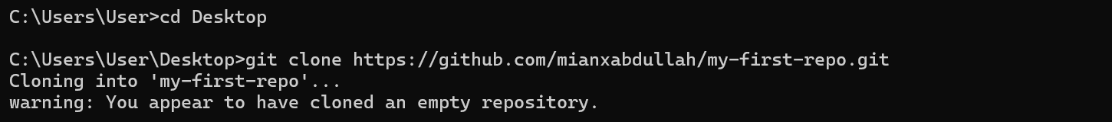
  - Cloned that repo
  - Made README.md file
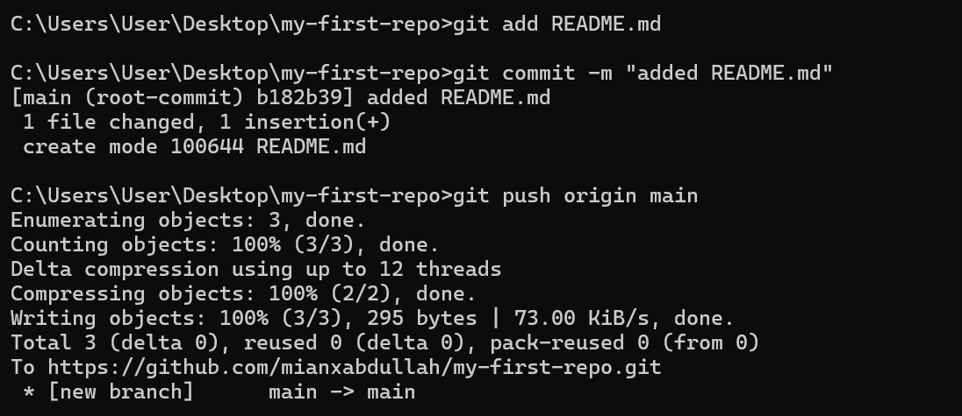
  - Add,commit,and push
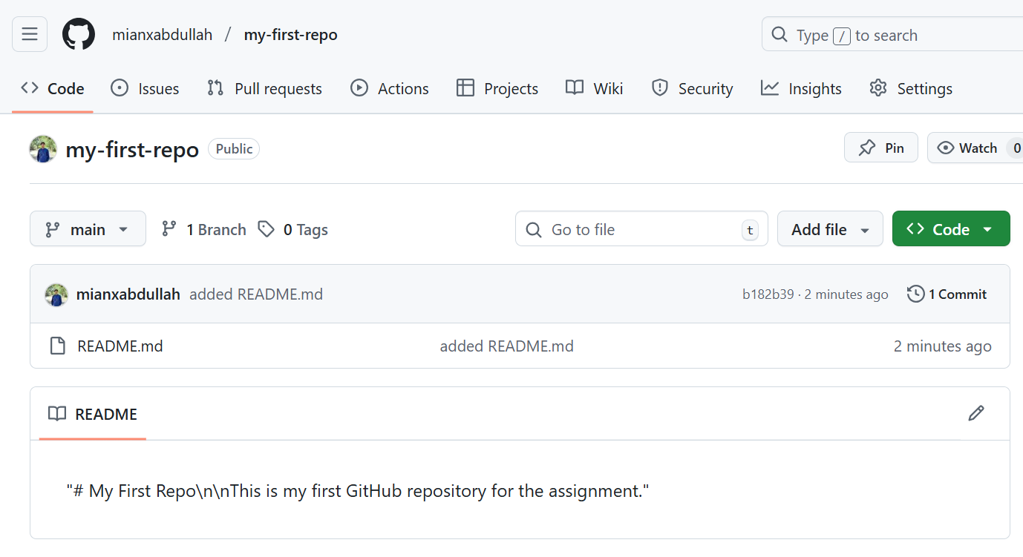
  - Updated repo after pushing README.md

Task2:
I generated an SSH key with ssh-keygen, added the public key to my GitHub account under Settings -> SSH and GPG keys, tested the connection with ssh -T git@github.com, and successfully cloned the repository using the SSH URL.

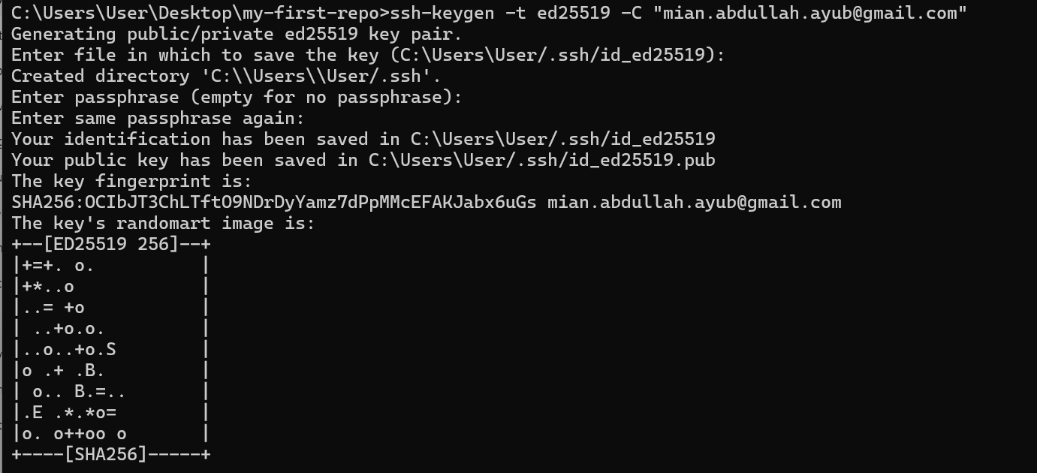
2.1 Created a ssh key
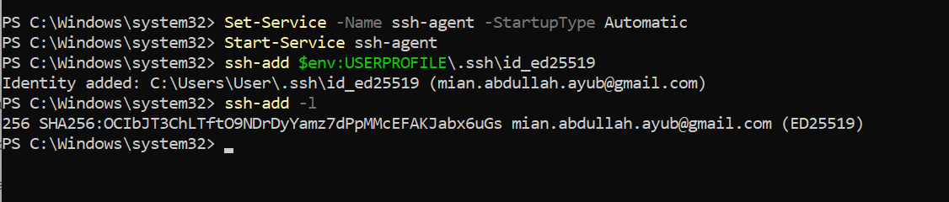
2.2
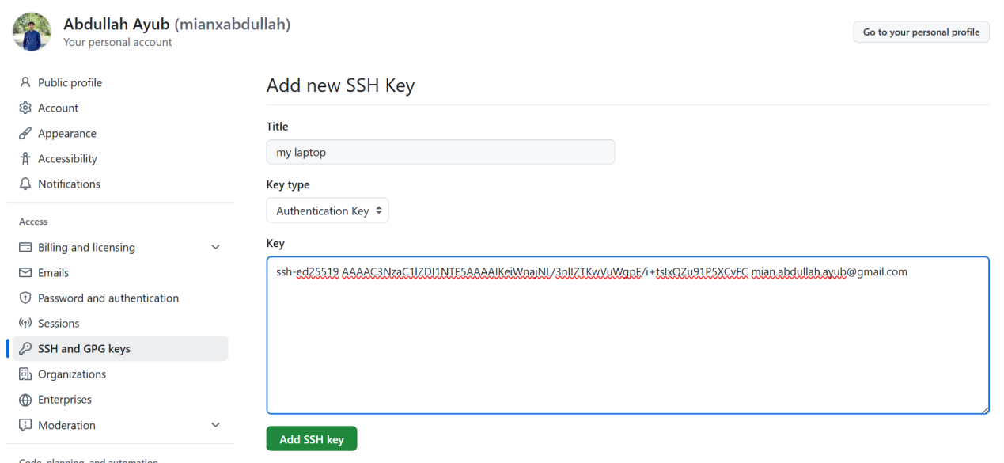
2.3 added the public key to my GitHub account
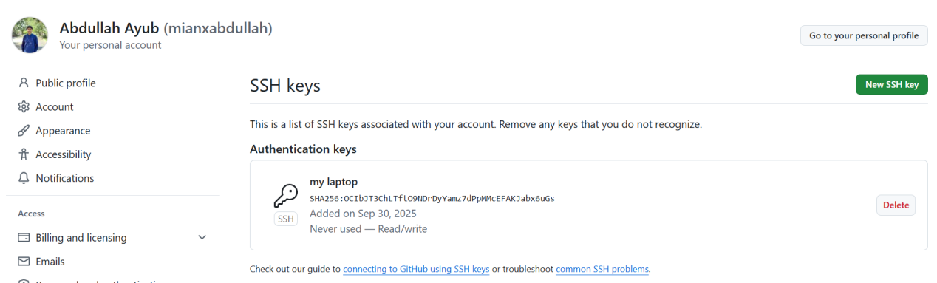
2.4 added key
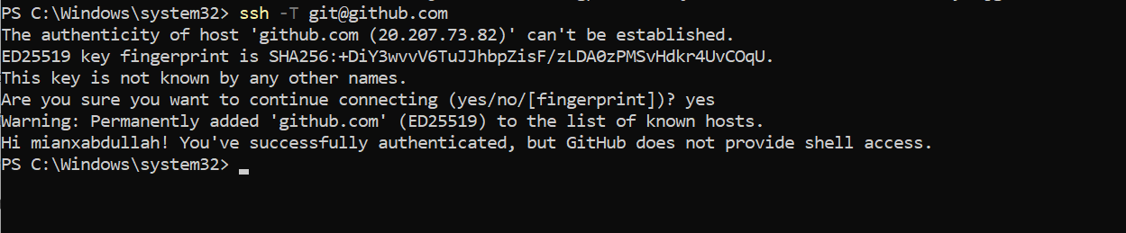
2.5 tested the connection
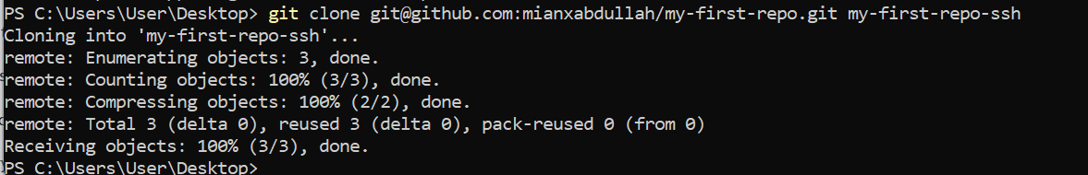
2.6 cloned the repository using the SSH URL

Task 3:
I created feature-branch, added feature.txt, committed and pushed the branch. Then I merged feature-branch into main locally and pushed main to GitHub.
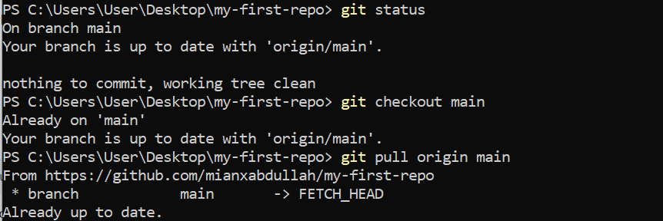
3.1 precautions
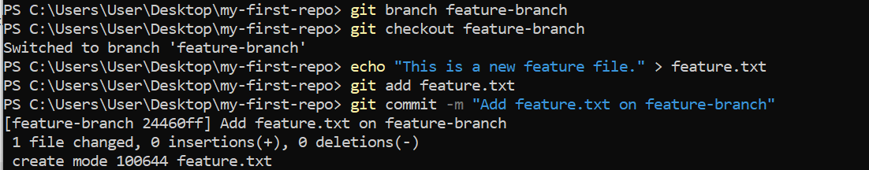
3.2 created feature-branch and added feature.txt

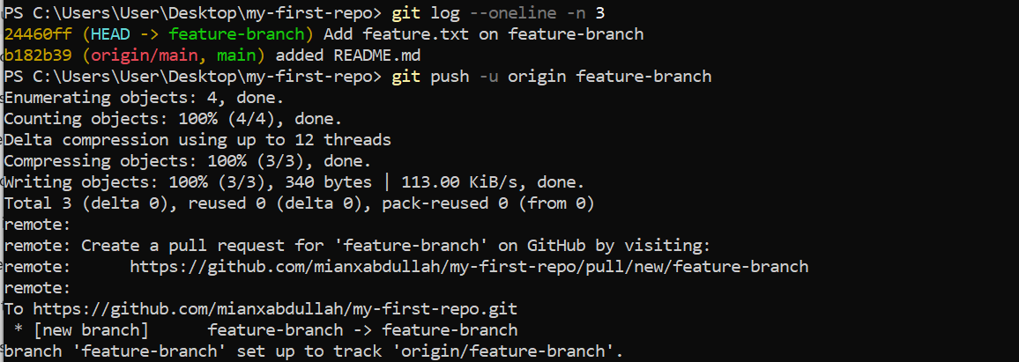
3.3 pushed to branch feature
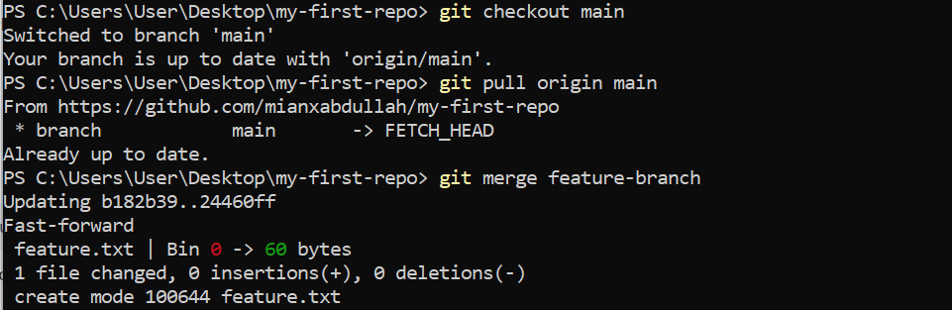
3.4 merge
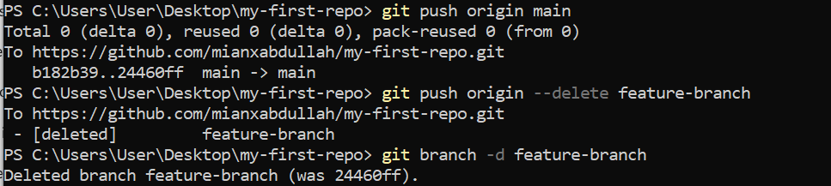
3.5 pushed from main
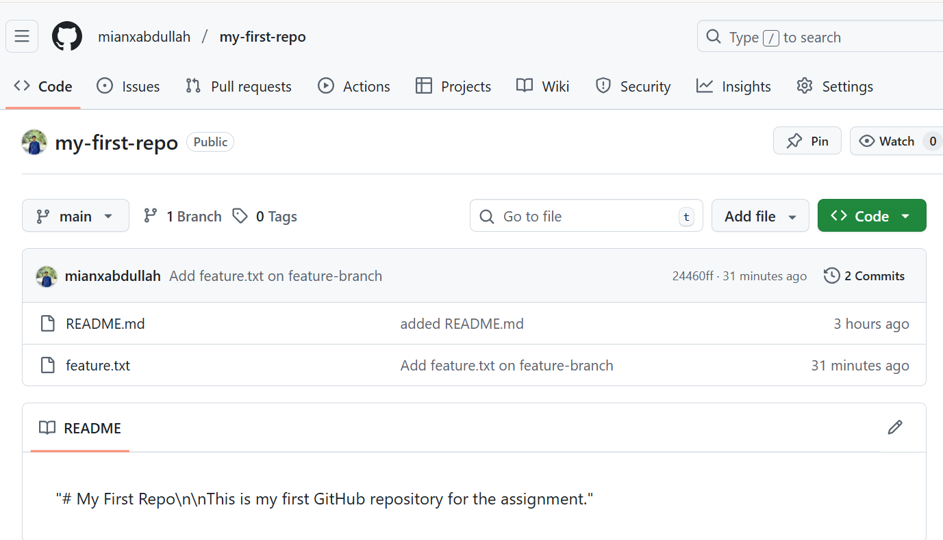
3.6 updated repo
Task4:
I created conflict-branch, made a conflicting change to README.md, attempted to merge into main, resolved the conflict by editing the file to remove conflict markers and selecting the final content, committed the resolved file, and pushed the changes to GitHub.
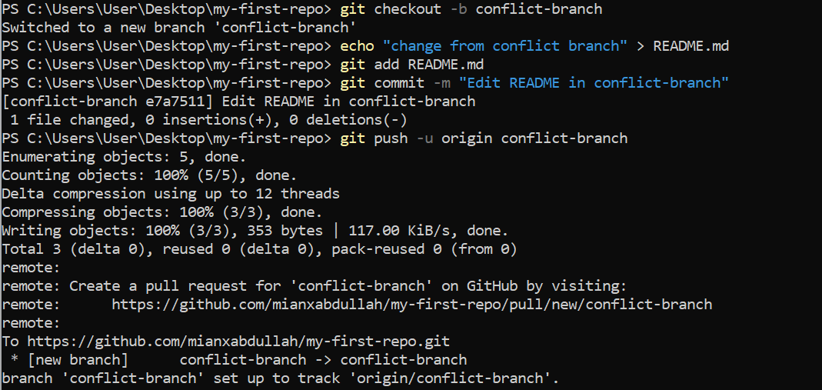
4.1 created conflict branch
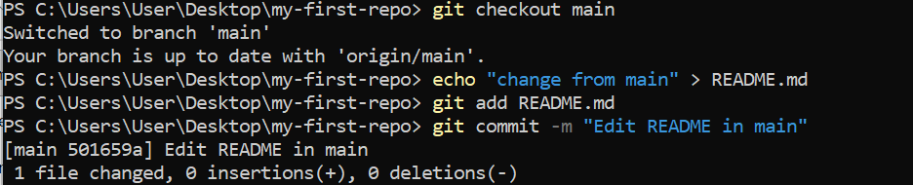
4.2 change from main
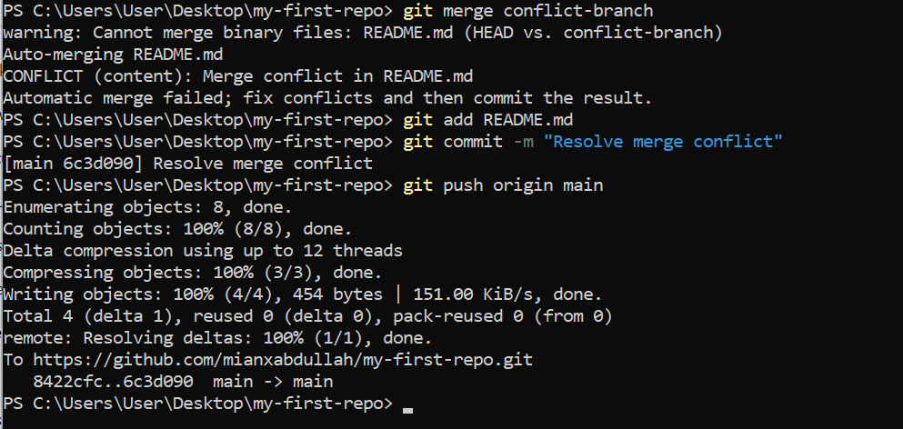
4.3 merge,resolved&pushed
Task5:
I added a collaborator through GitHub Manage access. The collaborator cloned the repo, made changes and pushed them. I pulled the changes into my local main branch and verified the updates
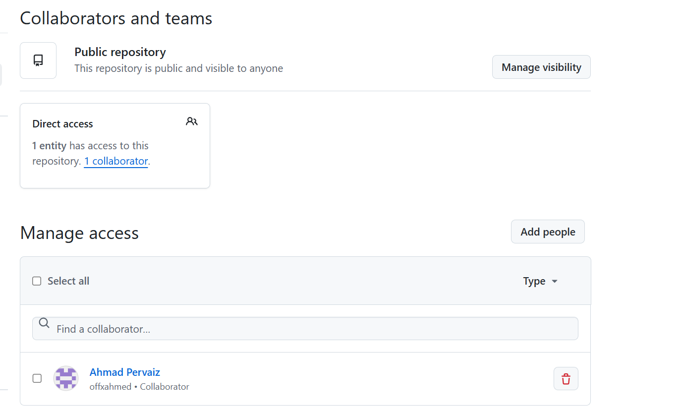
5.1 invited collaborator
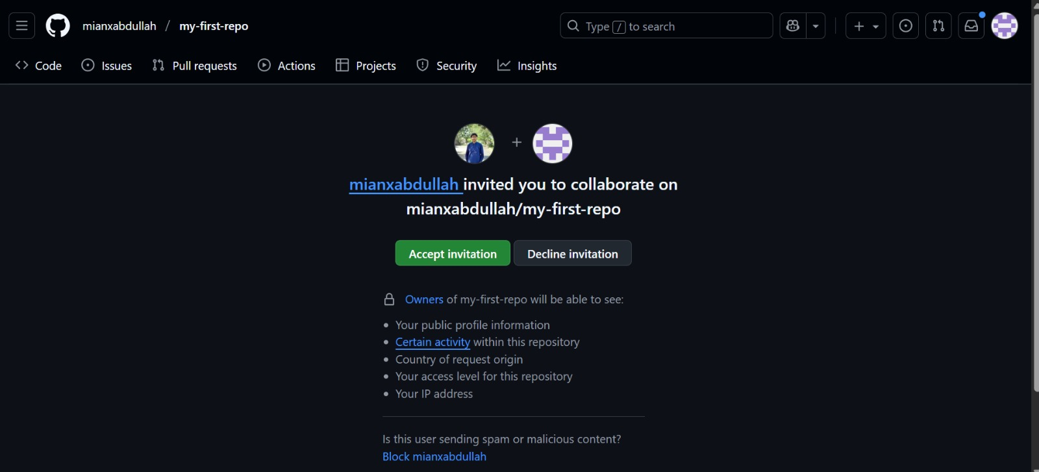
5.2 collaborator accepted
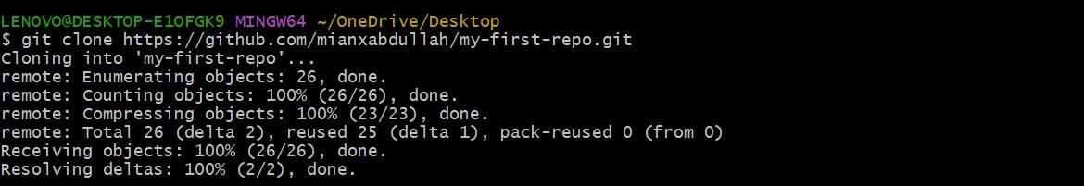
5.3 collaborator cloned repo
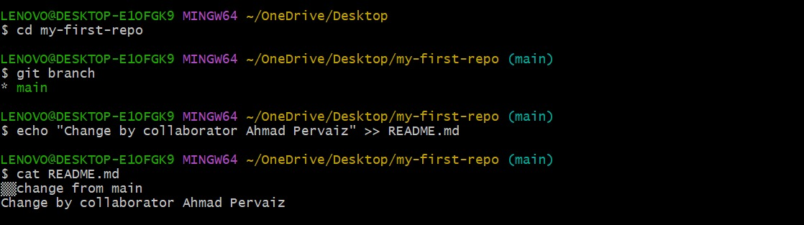
5.4 collaborator changed README.md
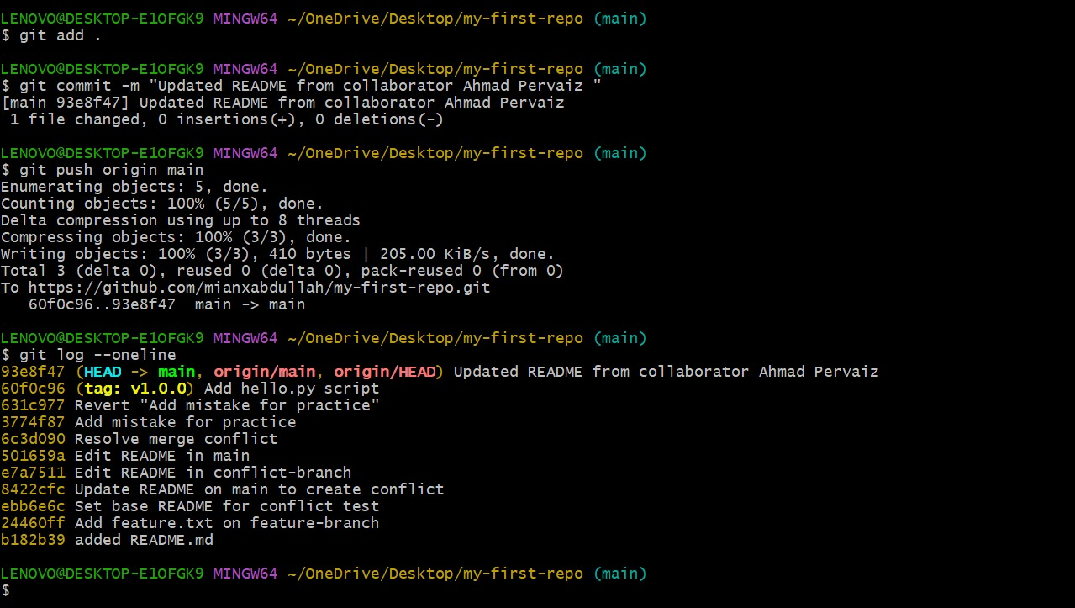
5.5 collaborator pushed changes

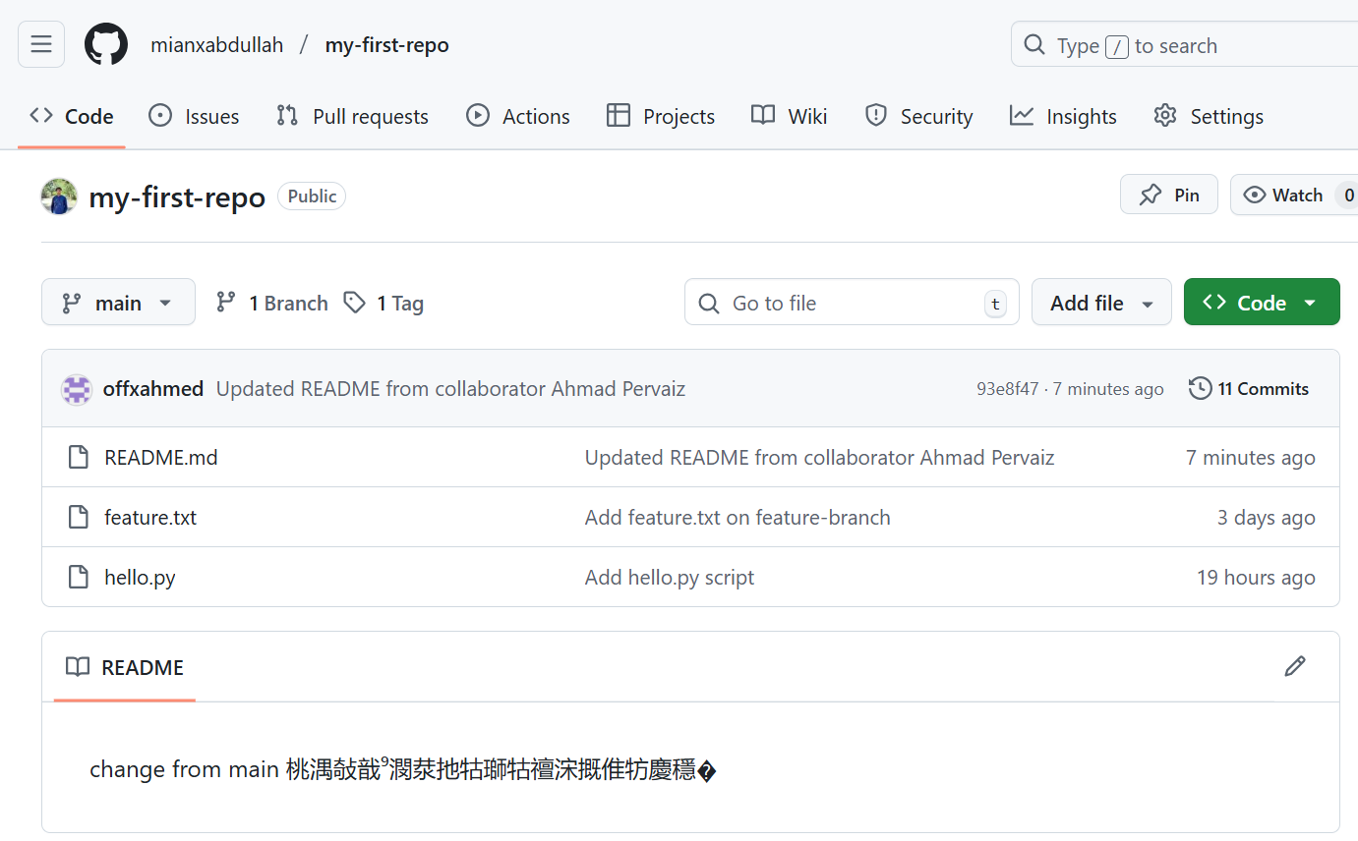
5.6 updated from collaborator

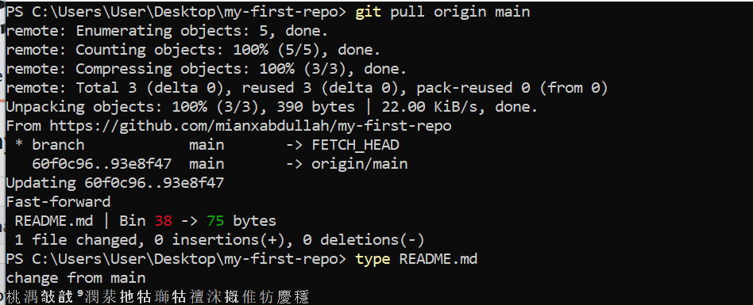
5.7 I pulled the changes made by collaborator

Task6:
i cleaned up the repository and practiced undoing mistakes. First, we deleted the unnecessary branch conflict-branch both locally and on GitHub to keep the repository tidy. Then, we deliberately added a mistake in README.md and committed it. Using git revert, we safely undid the mistake by creating a new commit that reversed the changes. Finally, we pushed the corrected main branch to GitHub, ensuring the repository was clean and up to date.

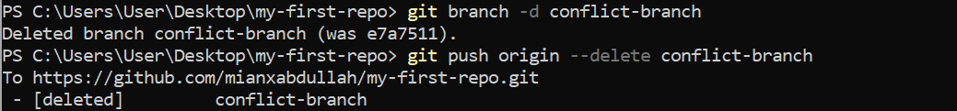
6.1 we deleted the unnecessary branch conflict-branch
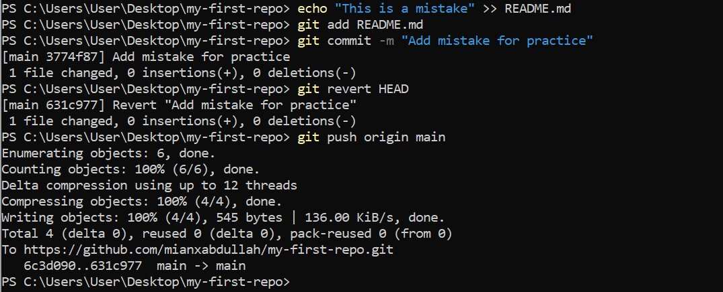
6.2 making mistake,revert and push
Task7:
we created a Python script hello.py that prints a message, committed and pushed it to the repository, and then created a Git tag v1.0.0 for this version. Using the tag, we drafted and published a release on GitHub.

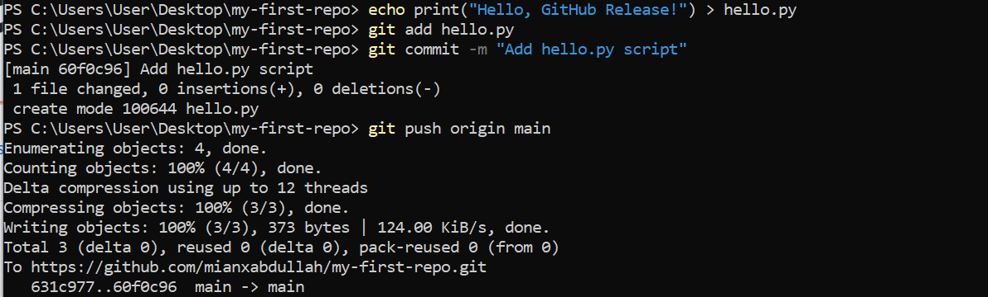
7.1 made hello.py file
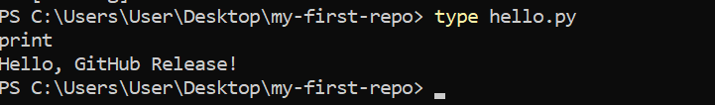
7.2 ran hello.py
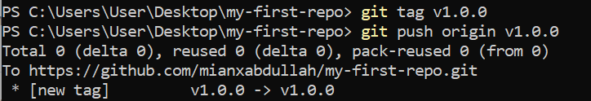
7.3 created a Git tag v1.0.0
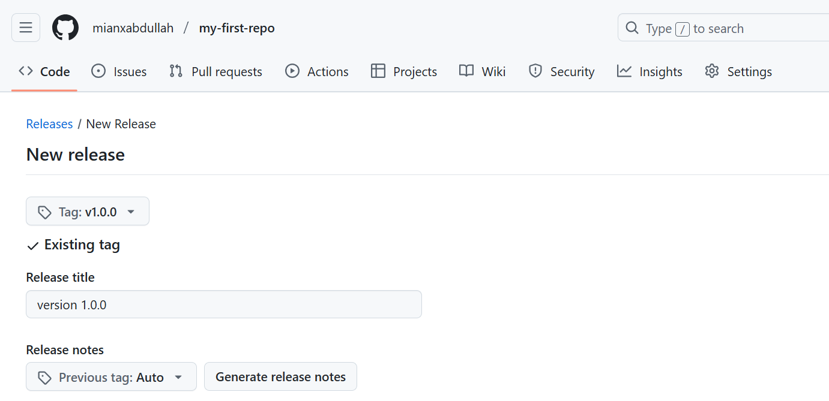
7.4 publish release

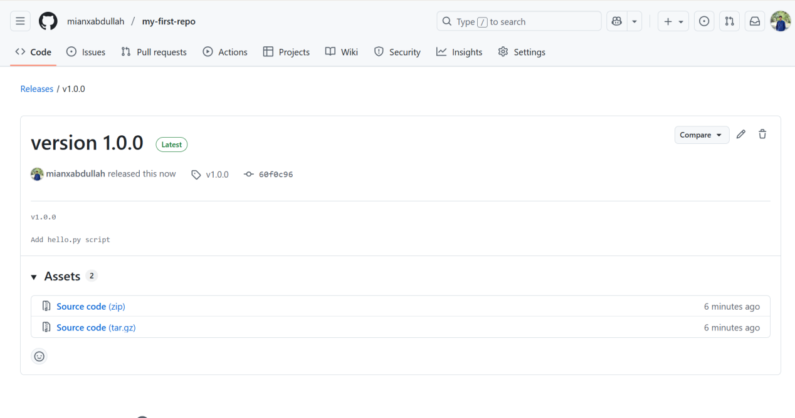
7.5 published

